Ordered List

# Program 1:

<html>

  <head>

    <title>work1</title>

  </head>

  <body>

    <h1>ORDERED LIST</h1>

    <ol type="A">

      <li>APPLE</li>

      <li>ORANGE</li>

      <li>GRAPES</li>

    </ol>

    <ol type="1">

      <li>APPLE</li>

      <li>ORANGE</li>

      <li>GRAPES</li>

    </ol>

    <ol type="a">

      <li>APPLE</li>

      <li>ORANGE</li>

      <li>GRAPES</li>

    </ol>

    <ol type="i">

      <li>APPLE</li>

      <li>ORANGE</li>

      <li>GRAPES</li>

    </ol>

    <ol type="I">

      <li>APPLE</li>

      <li>ORANGE</li>

      <li>GRAPES</li>

    </ol>

  </body>

</html>

# OutPut :

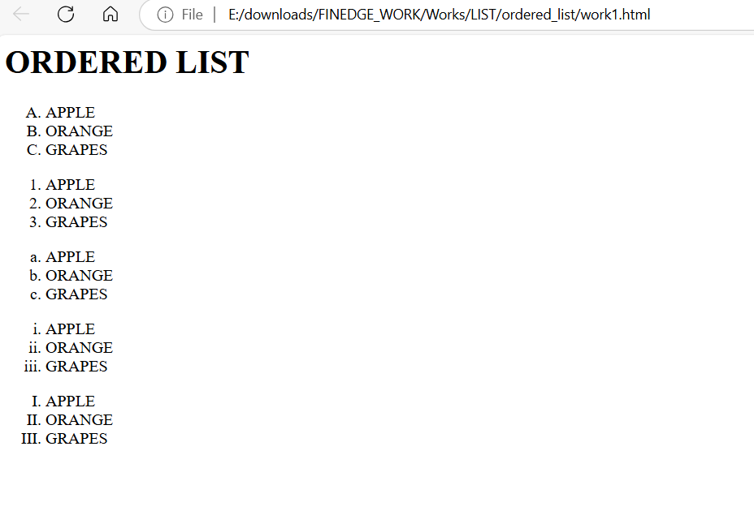

# Program 2 :

<html>

<head>

    <title>work3</title>

</head>

<body>

    <h1>ORDERED LIST</h1>

    <ol type="A">

        <li><img src="https://encrypted-tbn0.gstatic.com/images?q=tbn:ANd9GcQDBJs8O8bT9rxdPm0UUvM7FUjfudubqU4a3A&s" height="100px" width="100px"></li>

        <li><img src="https://encrypted-tbn0.gstatic.com/images?q=tbn:ANd9GcQo8G3tLIWUDKqA_KPah80Zz0N_lIZQ5Mb3ww&s" height="100px" width="100px"></li>

    </ol>

    <ol type="1">

        <li><img src="https://encrypted-tbn0.gstatic.com/images?q=tbn:ANd9GcQDBJs8O8bT9rxdPm0UUvM7FUjfudubqU4a3A&s" height="100px" width="100px"></li>

        <li><img src="https://encrypted-tbn0.gstatic.com/images?q=tbn:ANd9GcQo8G3tLIWUDKqA_KPah80Zz0N_lIZQ5Mb3ww&s" height="100px" width="100px"></li>

    </ol>

    <ol type="a">

        <li><img src="https://encrypted-tbn0.gstatic.com/images?q=tbn:ANd9GcQDBJs8O8bT9rxdPm0UUvM7FUjfudubqU4a3A&s" height="100px" width="100px"></li>

        <li><img src="https://encrypted-tbn0.gstatic.com/images?q=tbn:ANd9GcQo8G3tLIWUDKqA_KPah80Zz0N_lIZQ5Mb3ww&s" height="100px" width="100px"></li>

    </ol>

    <ol type="i">

        <li><img src="https://encrypted-tbn0.gstatic.com/images?q=tbn:ANd9GcQDBJs8O8bT9rxdPm0UUvM7FUjfudubqU4a3A&s" height="100px" width="100px"></li>

        <li><img src="https://encrypted-tbn0.gstatic.com/images?q=tbn:ANd9GcQo8G3tLIWUDKqA_KPah80Zz0N_lIZQ5Mb3ww&s" height="100px" width="100px"></li>

    </ol>

    <ol type="I">

        <li><img src="https://encrypted-tbn0.gstatic.com/images?q=tbn:ANd9GcQDBJs8O8bT9rxdPm0UUvM7FUjfudubqU4a3A&s" height="100px" width="100px"></li>

        <li><img src="https://encrypted-tbn0.gstatic.com/images?q=tbn:ANd9GcQo8G3tLIWUDKqA_KPah80Zz0N_lIZQ5Mb3ww&s" height="100px" width="100px"></li>

    </ol>

</body>

</html>

# Output:

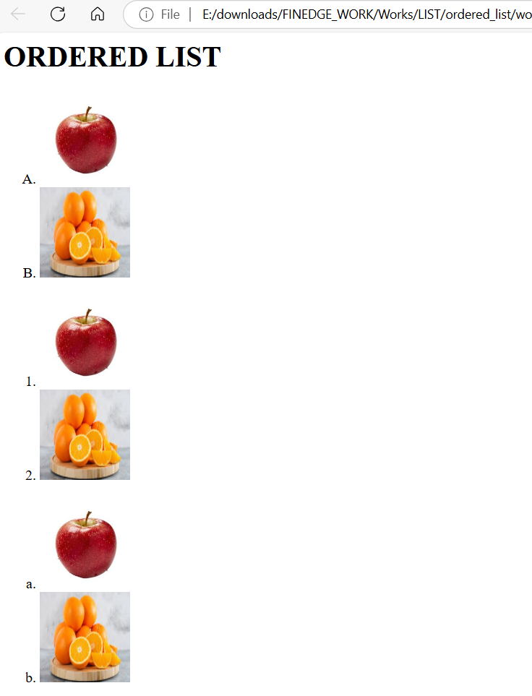

# Program 3 :

<html>

<head>

    <title>work9</title>

</head>

<body>

        <ol type="A">

            <li>

            <a href="work10.html">

                <img src="https://encrypted-tbn0.gstatic.com/images?q=tbn:ANd9GcQrv1vfsR3ZwvnMHK7l-w1LHUbUzgTbgkVg_Q&s" height="100" width="100">

            </a>

            </li>

            <li>

            <a href="work11.html">

                <img src="https://encrypted-tbn0.gstatic.com/images?q=tbn:ANd9GcS9LYNTKRpxdLLJsktkw4bbPqoyhQrrBshPIA&s" height="100" width="100">

            </a>

            </li>

            <li>

            <a href="work12.html">

                <img src="https://static.toiimg.com/thumb/msid-77520689,width-400,resizemode-4/77520689.jpg" height="100" width="100">

            </a>

            </li>

            <li>

            <a href="work13.html">

                <img src="https://encrypted-tbn0.gstatic.com/images?q=tbn:ANd9GcS7Rlokp6SbZWysjYEvVMEQ1MU0aFzXBnRCkg&s" height="100" width="100">

            </a>

            </li>

        </ol>

</body>

</html>

# OutPut :

